tomcat Installation on Centos 7

Apache Tomcat is an open source implementation of the Java Servlet, JavaServer Pages, Java Expression Language and Java WebSocket technologies. It is one of the most widely adopted applications and web servers in the world today. Tomcat is simple to use and has a robust ecosystem of add-ons.

launch Centos 7 instance

security groups --- 80,8080,22 allow

login to putty

# yum update -y

Before heading up for the Tomcat installation, make sure you must have **JAVA** installed on your Linux

# yum install java-1.8.0-openjdk-devel

#java -version --------Check java version

download tomcat tar file

# wget http://mirrors.estointernet.in/apache/tomcat/tomcat-9/v9.0.24/bin/apache-tomcat-9.0.24.tar.gz

# tar -xvf apache-tomcat-9tar.gz ---------extract tar file

#ls

# mv apache-tomcat-9tar.gz /opt/tomcat9 ------------move the tar file /opt directory

# useradd -M -d /opt/tomcat9 -s /sbin/nologin tomcat ------------create tomcat user

# chown -R tomcat. /opt/tomcat9 --------------chenge ownertship

# cd /opt/tomcat9

# ls

# cd bin

# ./startup.sh---> start tomcat service

# ./shutdown.sh ---> stop tomcat service

# netstat -plant | grep :8080 --------- to check port numbers

VERIFY: type your public http://IP_Address:8080

# vim /opt/tomcat9/conf/tomcat-users.xml

at end of the file paste it

<role rolename="manager-gui"/>

<role rolename="manager-scripts"/>

<role rolename="manager-status"/>

<user username="manager" password="12345"

roles="manager-gui,manager-script,manager-status"/>

<roles rolename="admin-gui"/>

<user username="tomcat" password="12345" ----------------- user name and passwd .

roles="admin-gui,manager-gui"/>

</tomcat-users>

:wq--save and quit

# cd /opt/tomcat9

# find -name context.xml

# vim /opt/tomcat9/webapps/host-manager/META-INF/context.xml

allow <specify n/w address

allow |192\.168\.56\.--->this one allow whole sunet network

allow |192\.168\.56\.100-->this one allow specific host only

example

<!-- <Valve className="org.apache.catalina.valves.RemoteAddrValve"

allow="127\.\d+\.\d+\.\d+|::1|0:0:0:0:0:0:0:1" />-->

:wq

-----------------------------------

# vim /opt/tomcat9/webapps/manager/META-INF/context.xml

allow <specify n/w address

allow |192\.168\.56\.--->this one allow whole subnet network

allow |192\.168\.56\.100-->this one allow specific host only >-->

example

<!-- <Valve className="org.apache.catalina.valves.RemoteAddrValve"

allow="127\.\d+\.\d+\.\d+|::1|0:0:0:0:0:0:0:1" />-->

:wq

# cd /opt/tomcat9/bin

# ./shutdown.sh -------------start tomcat server

./startup.sh

http://IP_addres:8080

Login to server Manager .

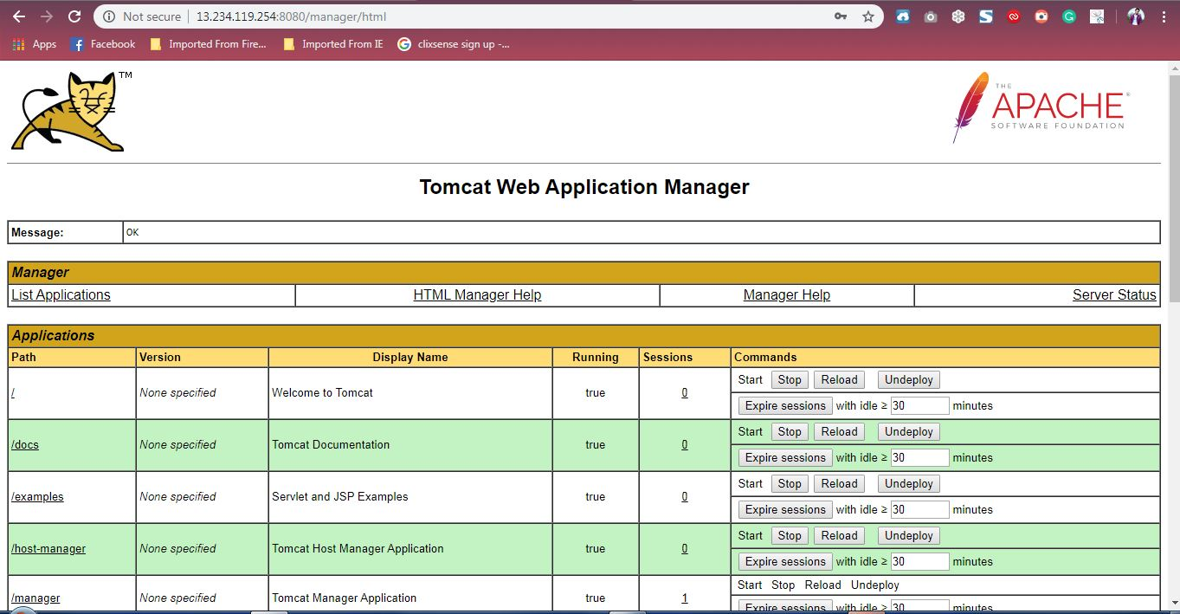

VERIFY

go to browser bar and type your tomcat ip address:8080

select manager and enter username and password, also

select admin roles,server status

see how to deploy sample java application in tomcat

-----------------------------------------------------------------------

Deploy war file ......

Downoad jenkis.war file ---- go to jenkins.war search to google

# wget https://updates.jenkins-ci.org/download/war/2.194/jenkins.war

# mv jenkis.war /opt/tomcat9/webapps

# ./shutdown.sh ------restart tomcat

Login to server manager to check jenkins.war file are not

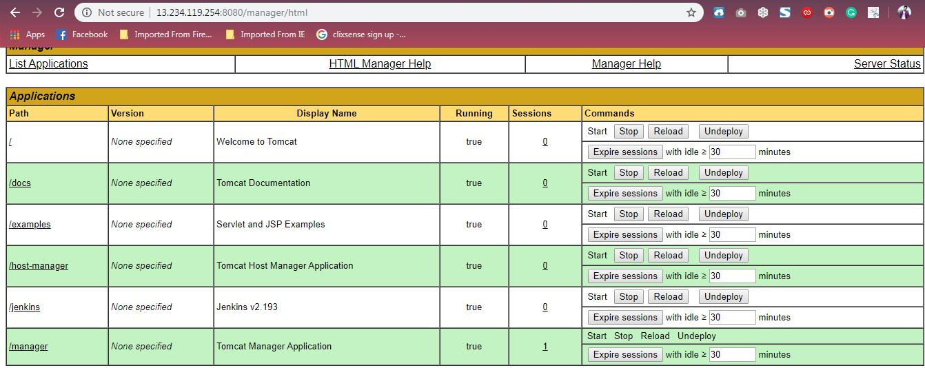

click on jenkis.war deploy the jenkis home page

[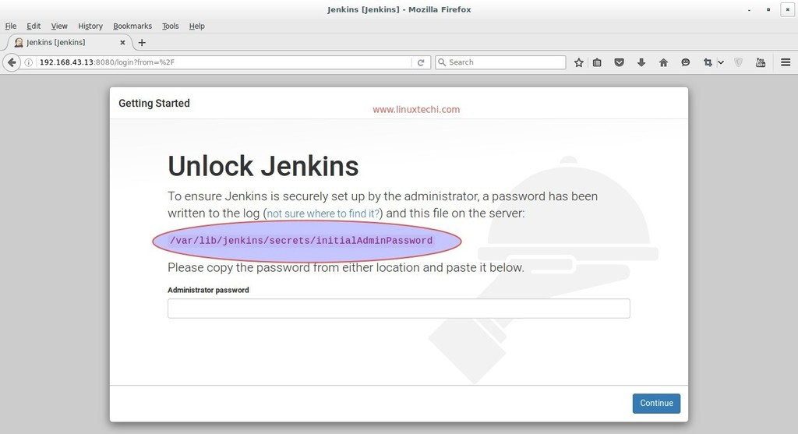](https://www.linuxtechi.com/wp-content/uploads/2016/08/Jenkins-administrator-password-centos7.jpg)

/var/lib/secrets/InitialAdminPassword -------Copy to past putty

# cat /var/lib/secrets/InitialAdminPassword ---- Showing passwd

login to jenkin home page .

